**AIM:** Write a C program to arrange a series of numbers using Insertion Sort

**ALGORITHM:**

1. Start with the second element (index = 1), treat the first element as sorted.
2. Compare the current element (key) with elements in the sorted part of the array.
3. Shift all elements greater than the key one position to the right.
4. Insert the key at its correct position.
5. Repeat for all elements until the array is sorted.

**CODE:**

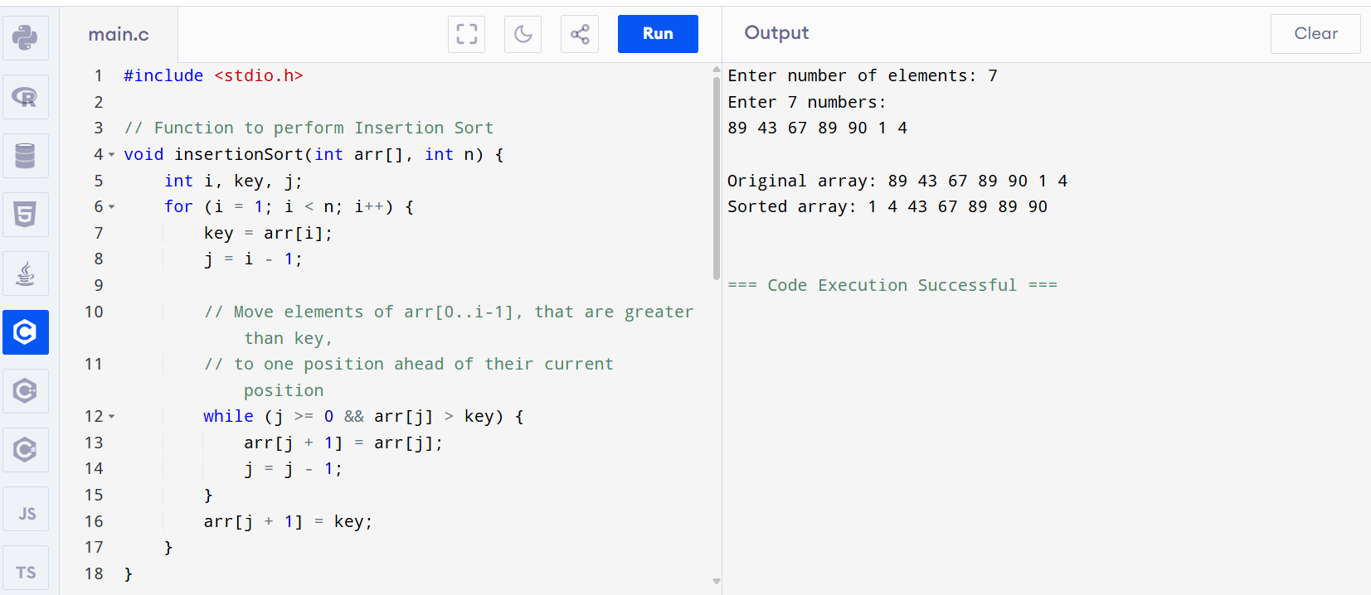

**OUTPUT:**

Enter number of elements: 7

Enter 7 numbers:

89 43 67 89 90 1 4

Original array: 89 43 67 89 90 1 4

Sorted array: 1 4 43 67 89 89 90